A000-ASIA- Indus-Female Figurine-Scarf framed by curls-Terracotta-3000 BCE 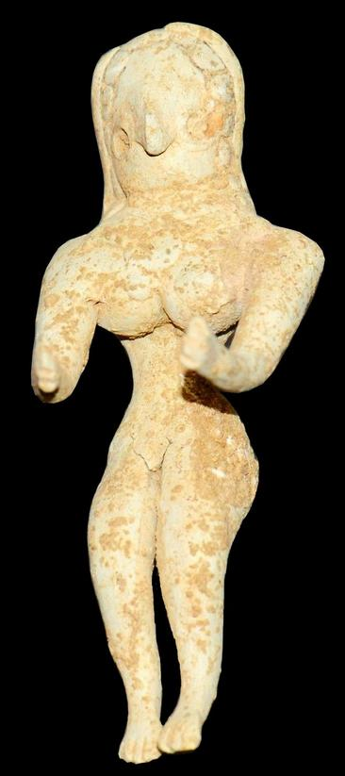

Fig. 1. Indus-Female figurine-Scarf framed by curls-Terracotta-3000 BCE

Case no.: 3.

Accession Number: A….

Formal Label: Indus-Female figurine-Scarf framed by curls-Terracotta-3000 BCE

**Display Description:**

This female figurine from Mehrgarh [Pakistan], c 3000 BCE, (Musée Guimet, Paris) is among the oldest in the Indus Valley and was prevalent even before pottery appeared. The more accurate terminology is “female figurine” because "mother goddess", implies that it had a cultic significance.

**LC Classification:** PK119

Date or Time Horizon: 3000 BCE

Geographical Area: Indus Valley

INCLUDEPICTURE "https://upload.wikimedia.org/wikipedia/commons/5/50/Carte_Indus.jpg" \* MERGEFORMATINET 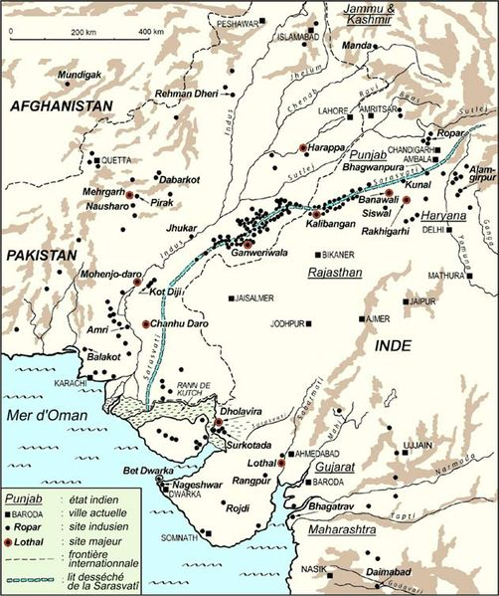

Cultural Affiliation: Indus

Media: terracotta, black pigment

Dimensions: H 10.1 cm.

Weight:

Condition: original

Provenance: Ex: European collection

**Discussion:**   
Figure wears a tall flared polos type headdress. The shoulders are broad and square with her arms extending downwards and slightly out.

**References:**

US $2,350.00

Culture- Indus Valley.  
  
Date-  3000 BCEMaterial- Terracotta.  
  
Condition- Intact, with custom display stand.  
  
Provenance- Ex: European art market; Ex: American private collection.  
Measurements- 4 3/8 in. High (10.4 cm.)

A very rare fertility statue, especially in such a state of preservation.